Credit One Default Customers Report  
Nick McCoy

# Statistics on Defaults

**1. Total Defaults**

30,000 Customers were analyzed and 22%, or 6636, defaulted.

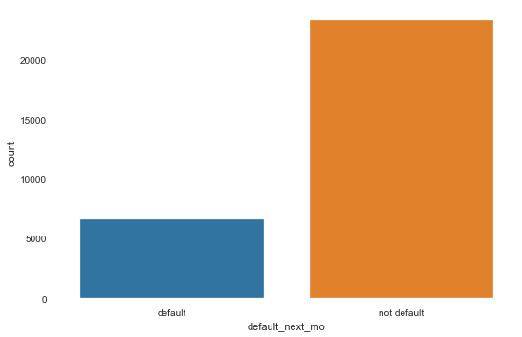

**2. Educational Relationship to Defaults**

The default rates among education levels were consistent with no major outlier.

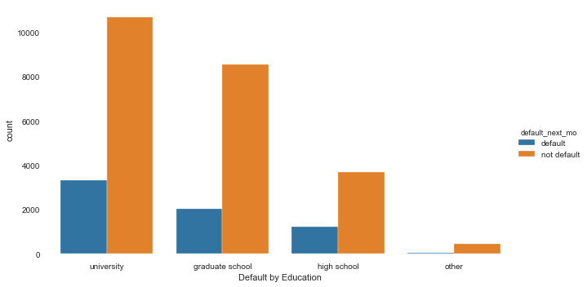

**3. Marital Status Relationship to Defaults**

The default rates of married vs. single customers does not show a major split, but the rate is slightly higher among single people but not significant enough to warrant further analysis.

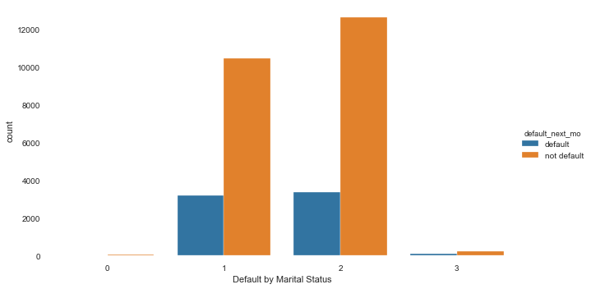

**4. Male vs. Female**

The default rates of male customers is slightly higher but not significant enough to warrant further analysis.

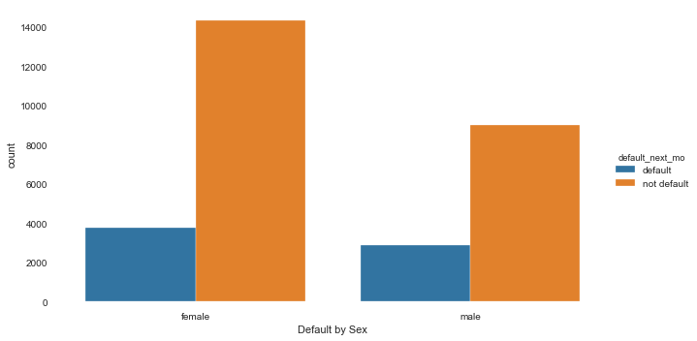

**5. Limit Balance**

Limit balances are skewed toward the lower level but there is not apparent relationship between limit levels and default rates, the rate is consistent.

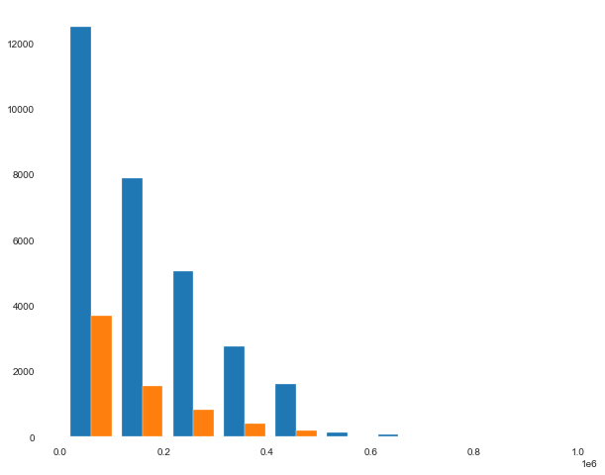

# Ensure Customer Pay their Loans Data Analysis

**Multi-point Analysis - Regression**

Regression analysis was performed to analyze whether using multiple factors could help identify what credit limit range a customer fit into. Simply put, the data points that correlated most to the limit balances were the payments and the education level. Even using the highly correlated data points, the accuracy of the model was only able to achieve around 42% and therefore the model was unuseable

**Logical Relations to Limit Balances**

In order to help predict what limit balance should be give to a specific customer it is only logical to use information that is available at the time of application. Such as, age, education, marital status and sex. When these data points were applied to the model the accuracy was even worse. In short, there is no useable correlation between the limit balance and the data given**.**

**Predicting Defaults**

Classifying customers as likely to default or not makes sense in this problem. A model was constructed that was able to predict with 80% accuracy whether a customer would default or not. Further analyses using decision trees is required to support this solution.